Logging Into Employee Self-Service (ESS)
For Terminated Employees
Updated | 4/20/22

Table of Contents
- Before You Begin
- Accessing ESS For Terminated EEs

Before You Begin
- This login method should be used by Terminated employees ONLY
- Beginning 4/20/22, Inactive (Leave & Seasonal Separation) employees can access ESS via single sign-on, which is the same login method used by Active employees
- For assistance getting logged in, reach out to IT Support (Mountain & Parent Company, Hospitality) or Human Resources
- The below instructions are intended for accessing employee self-service via the web, not mobile
  - Note: Google Chrome is the recommended browser
  - Note: Incognito browser windows are not recommended as they may cause issues with your two-step authentication

Accessing ESS For Terminated EEs
- Log into Kronos HCM using the following URL: https://prd01-hcm01.npr.mykronos.com/ta/6036623.login?NoRedirect=1
- On the Workforce Dimensions HCM login page, enter your employee ID as your username and your unique password, then click ‘Login’
  - Note: If you’re unsure of your employee ID, please connect with IT Support (Mountain & Parent Company, Hospitality) or Human Resources
  - Note: If you don’t know your password, click the ‘Forgot your password?’ hyperlink located beneath the blue ‘Login’ button and follow the prompts to reset your password
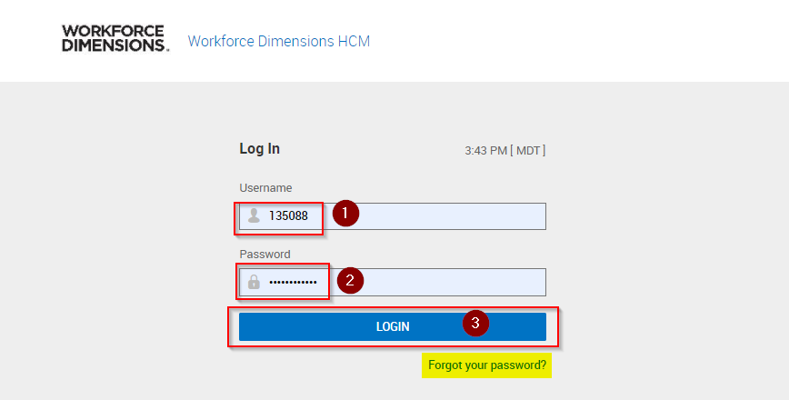

- Complete your two-step authentication by selecting a delivery method to receive a virtual code either by Text, Voice, or Email, then click the blue ‘SEND’ action button
  - Note: The contact details for each delivery method will populate based off of the contact details tied to your record in Kronos HR, however, if you do not have a cell phone (Text delivery method), home phone (Voice delivery method), or primary email address (Email delivery method) on file, you can enter these contact details prior to choosing your delivery method
  - Note: After clicking ‘SEND’, you should see an informational message pop up above the ‘Methods’ section confirming that your code was sent successfully and / or if there was an error with the code delivery method

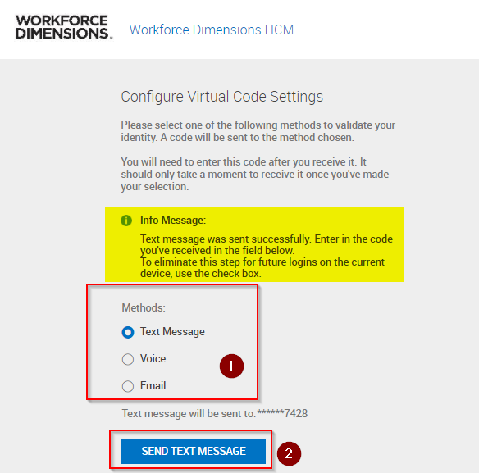

- Once you receive your virtual code, enter it into the text box provided, then click ‘Continue’
  - Note: If you choose to receive your virtual code via email, the message will be sent from noreply@kronos.com with the subject ‘ACTION REQUIRED By User’
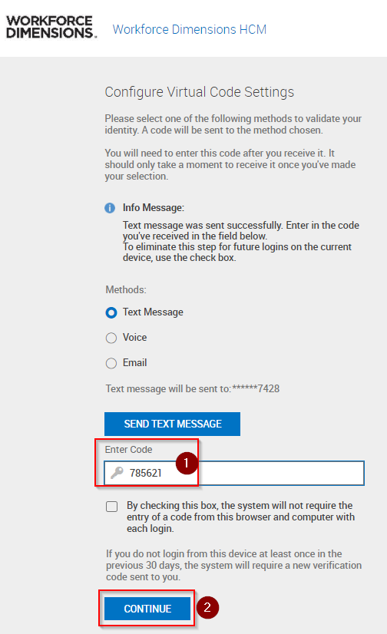

- One you’re logged in, navigate to your ‘Self-Service’ dashboard and click ‘My Account’ under the ‘Start’ widget to expand your self-service menu shortcuts
