1. Sign into account.microsoft.com
2. Select “Change Password” 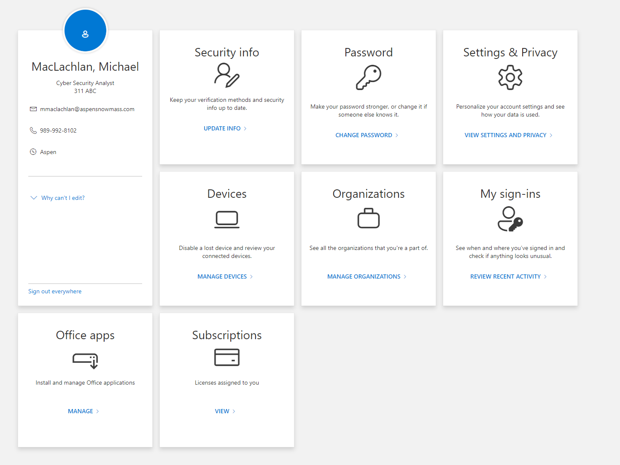
3. Follow re-enter your old password, create a new one, and click submit